207SE Lab 2 – Linux command-line

1. Create a directory called Portfolio1 in your home directory and make it read/write/executable only for you and your group and executable for others.

mkdir Portfolio1

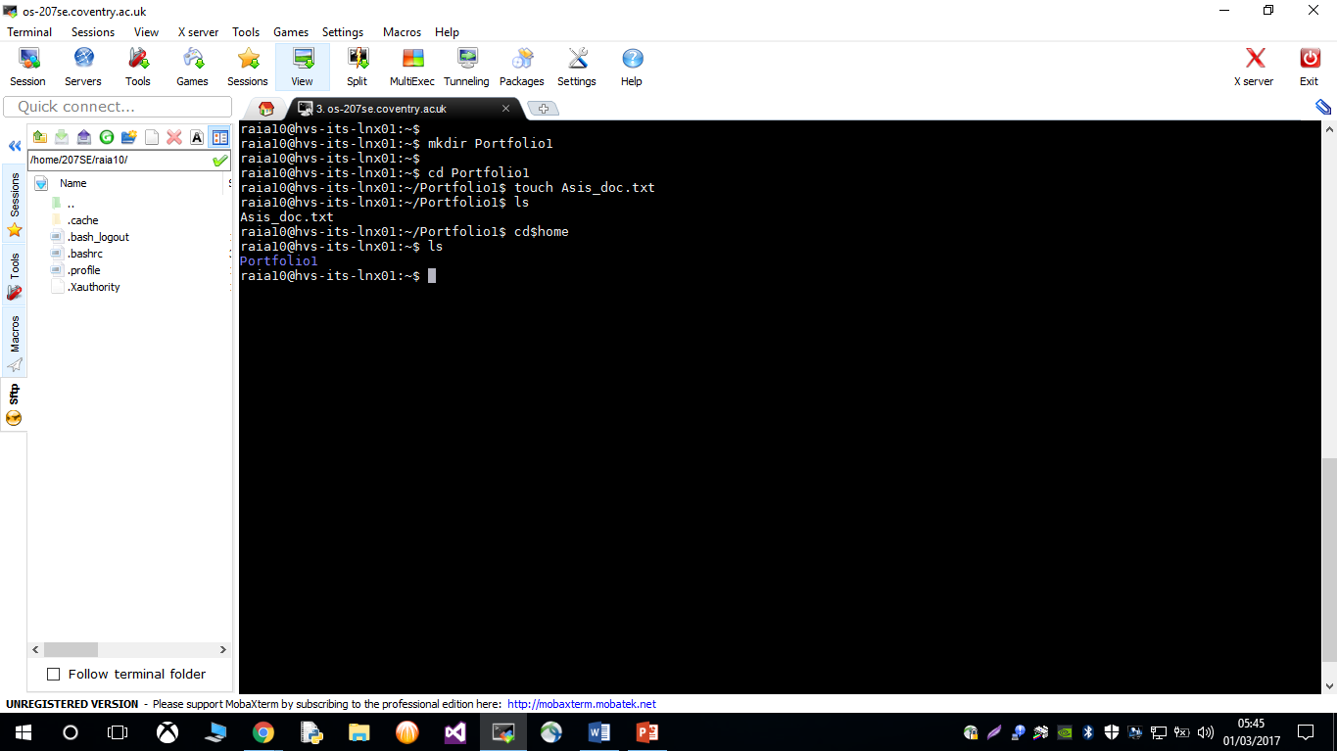

Portfolio directory created in Home directory

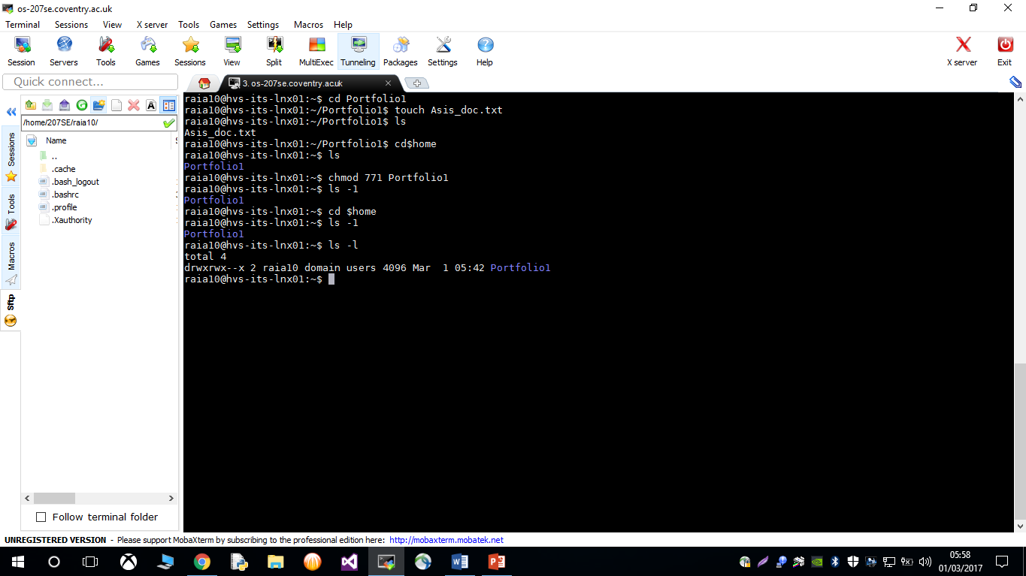

R/W/X permission set for me and my group

X permission set for others

1. Download the script [http://www.centerkey.com/tree/tree.sh to](http://www.centerkey.com/tree/tree.sh) your home directory using wget and make it executable.

*type man wget to find out how it works.*

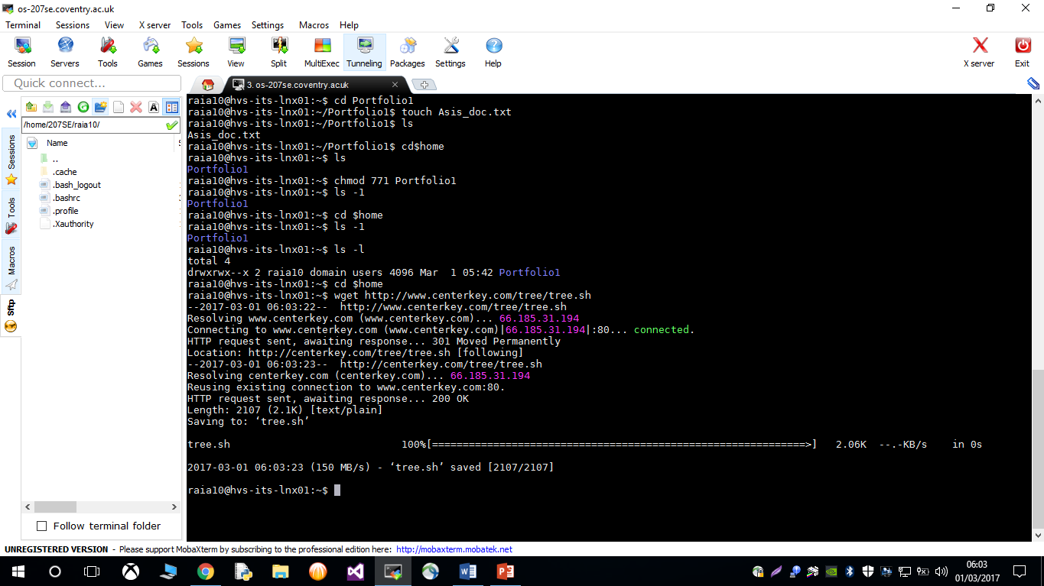

Script downloaded into home directory and saved as tree.sh

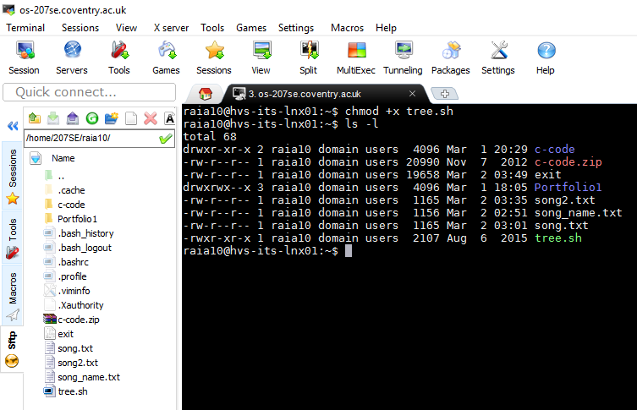

Tree.sh directory made executable

1. Create a 207se directory in your Portfolio1 directory.
   * + Create numbered directories for this week and last week. i.e. lab1 and lab2.

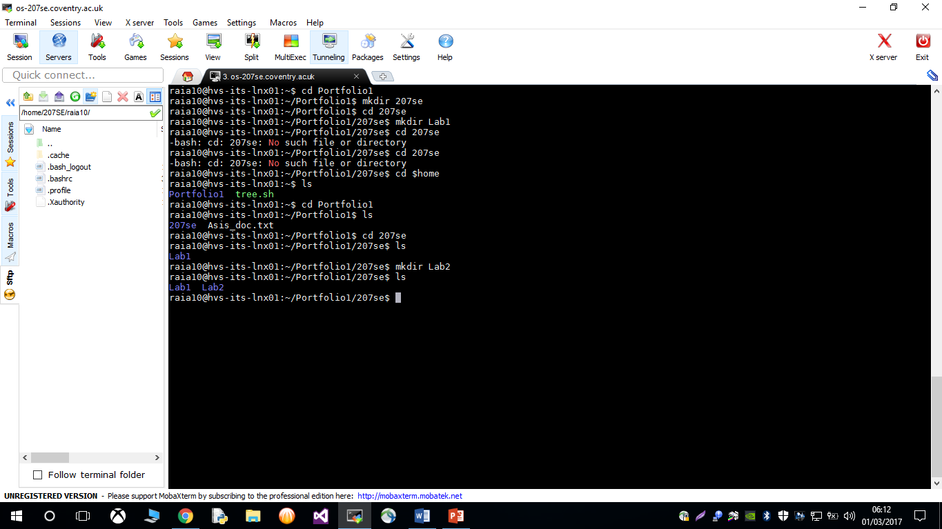* 207se directory created into Portfolio 1

* Lab 1 and Lab 2 directories created into 207se directory.

* + - Transfer your week 1 evidence into the folder called lab1. •

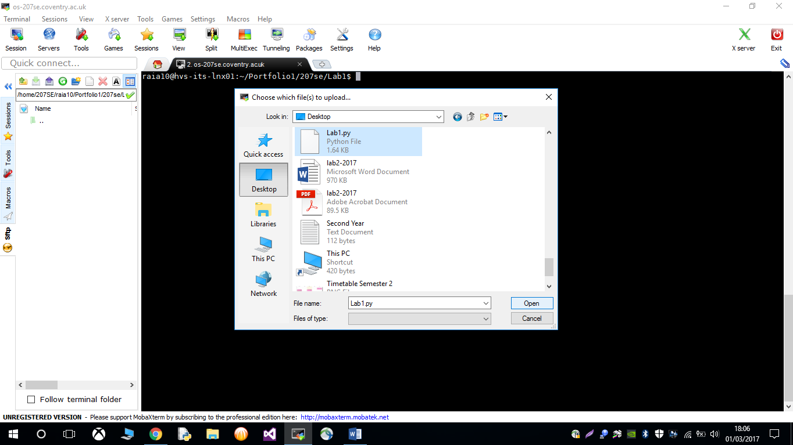

I uploaded Week 1 evidence into Lab1.

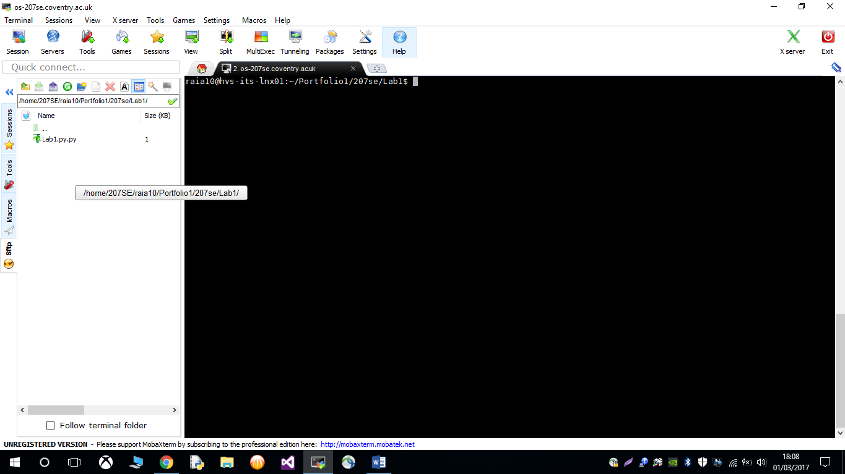

* + - Show your evidence using tree.sh

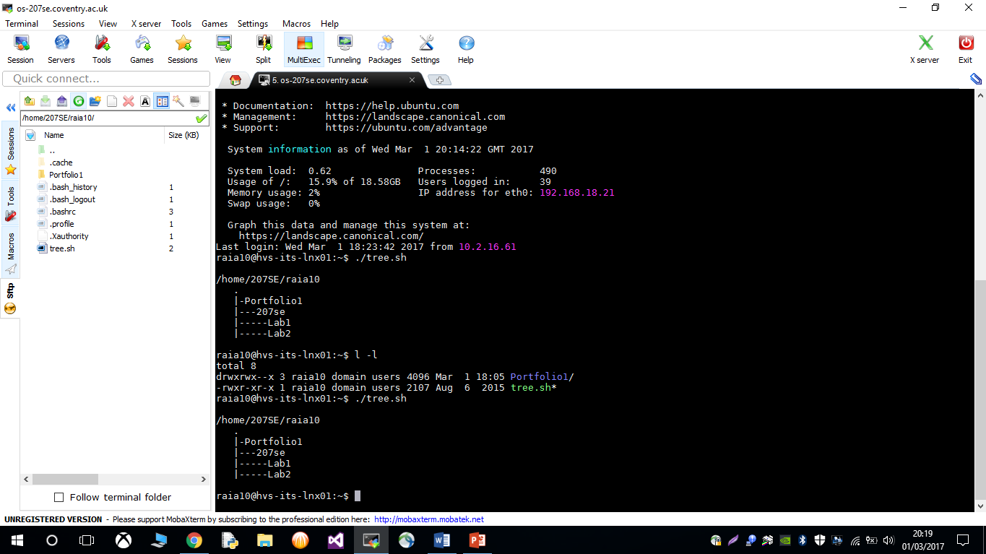

1. Display todays date and using the cal comm

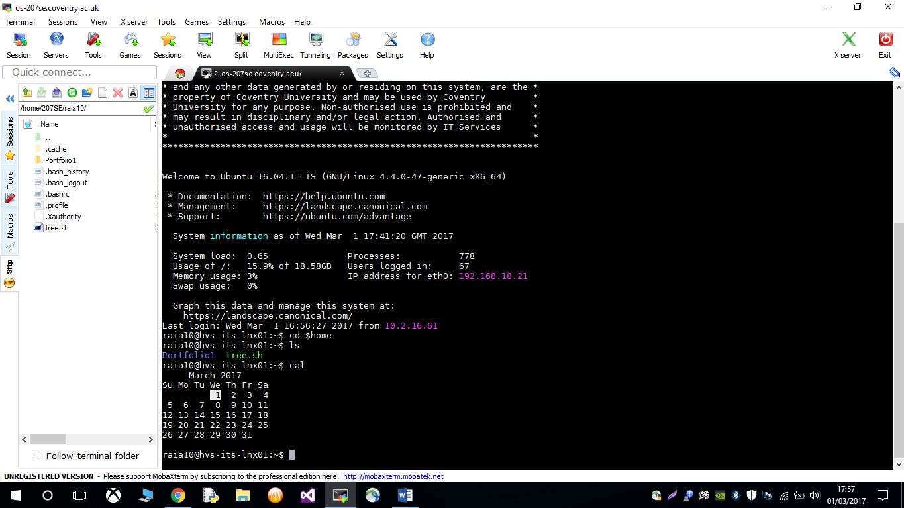

show the month that you were born.

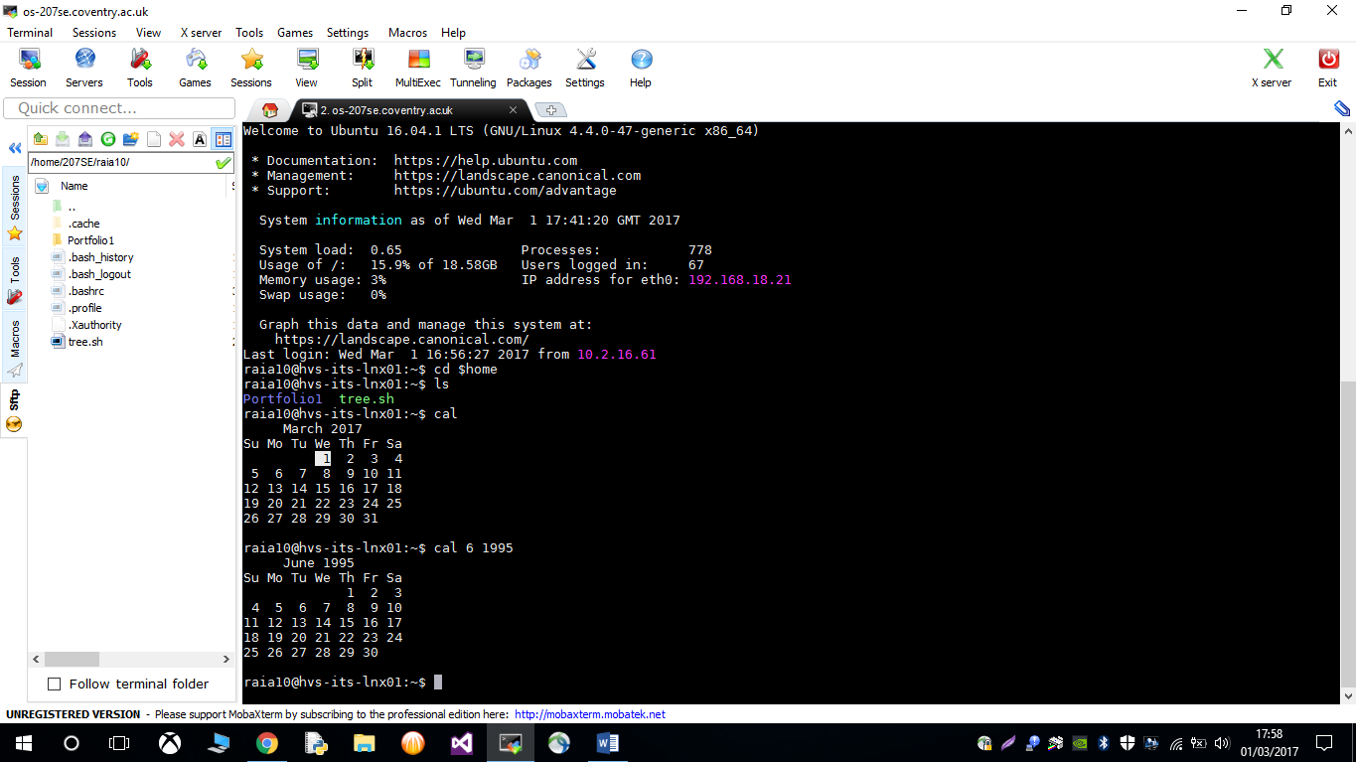

1. Move into the lab1 directory and use the appropriate command to show the current directory.

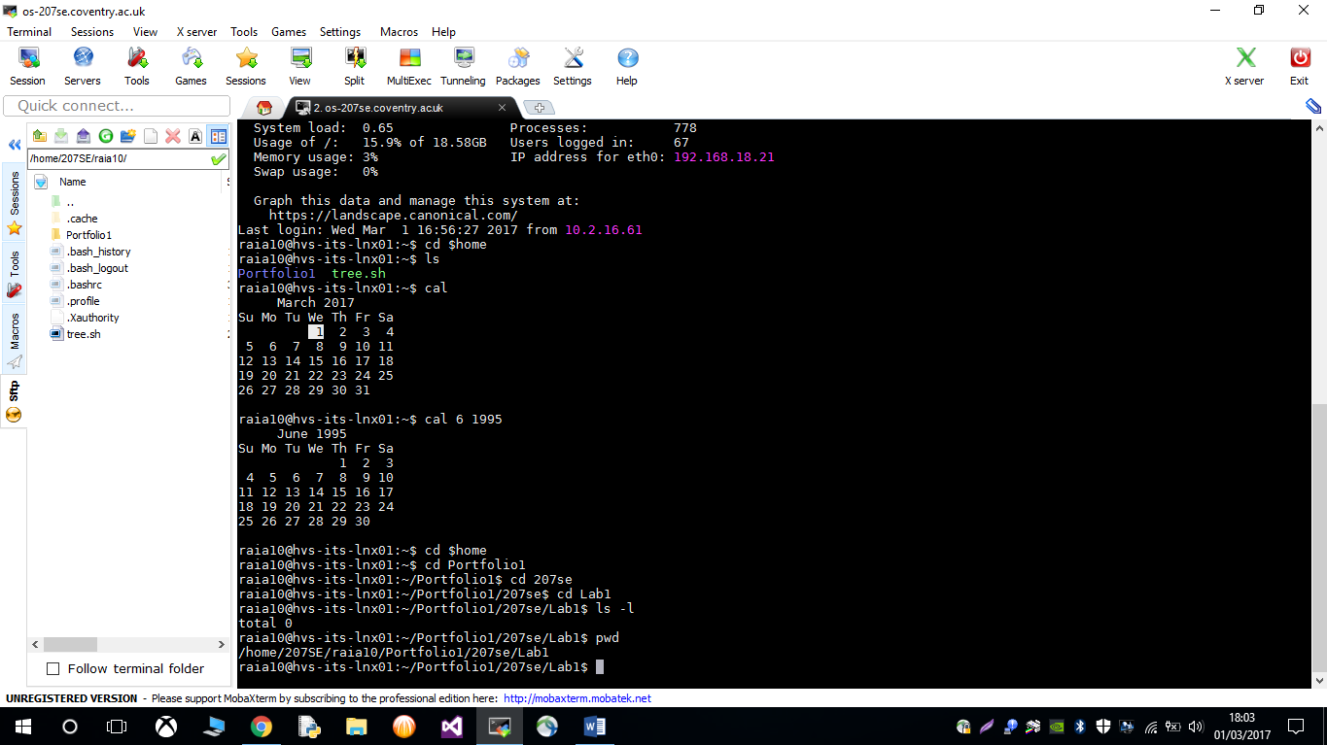

1. Find out what talk, write and wall are for.

1. Find out how to prevent the effects of those three commands from interrupting you. What command can you use?

1. Create a text file called song.txt and, using an editor of your choice, enter a random generated song from<http://writerbot.com/lyrics>

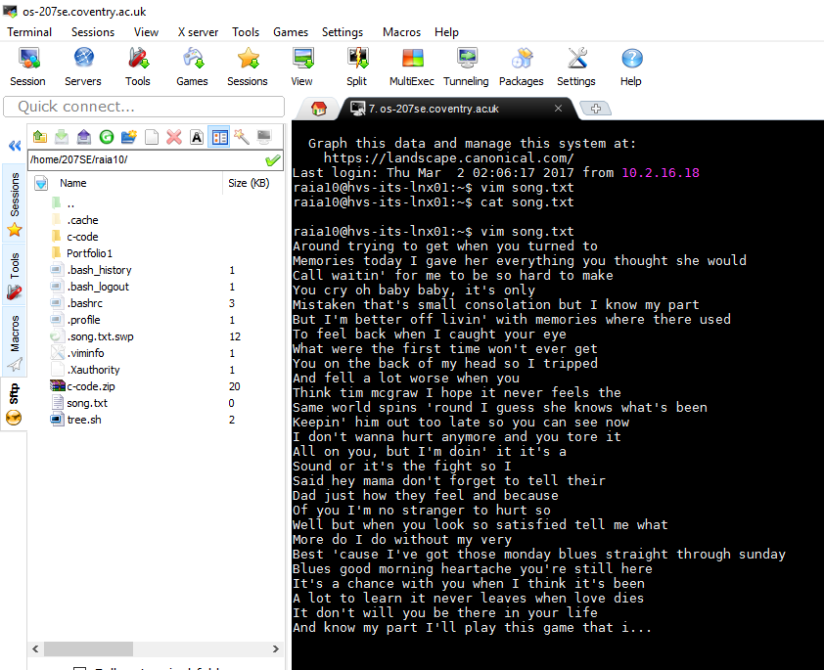

* + **Use wc to count the characters, words and lines in the file.**

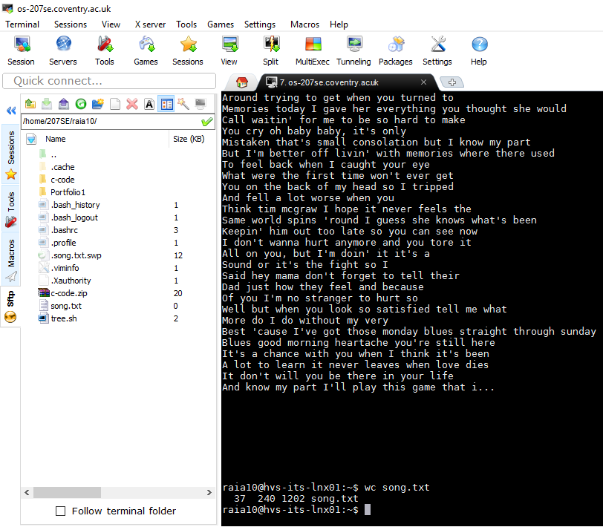

* + **Use grep to show only lines containing "and" and the number of these lines in the document**



* + Use cat to show the contents of the file.

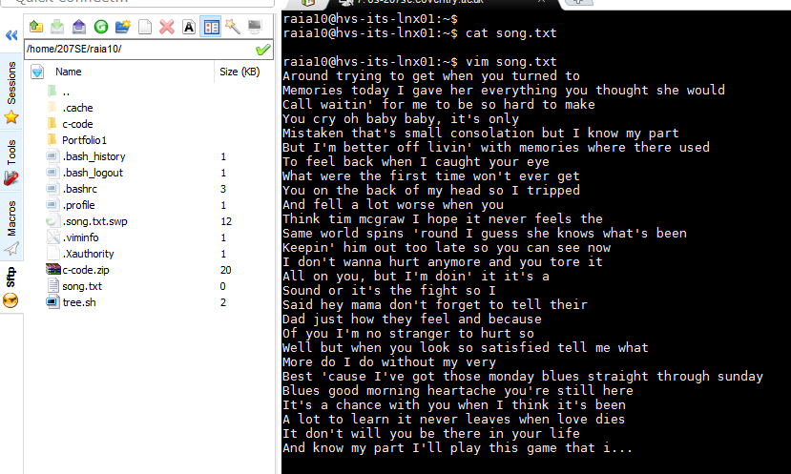

* + Open the song.txt file with a text editor and randomly replace any two words with your first and second names, and save the file as song_name.txt. Use the appropriate Linux command to see if they differ and how they differ.

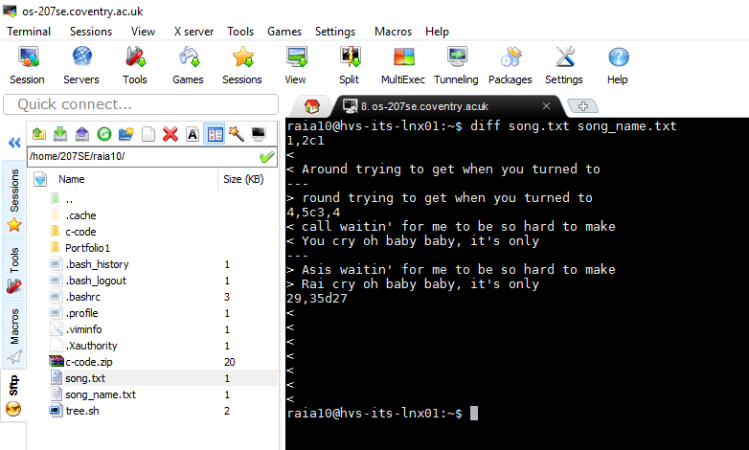

* + Use sort to sort the song.txt file and redirect the output to a new file called song2.txt

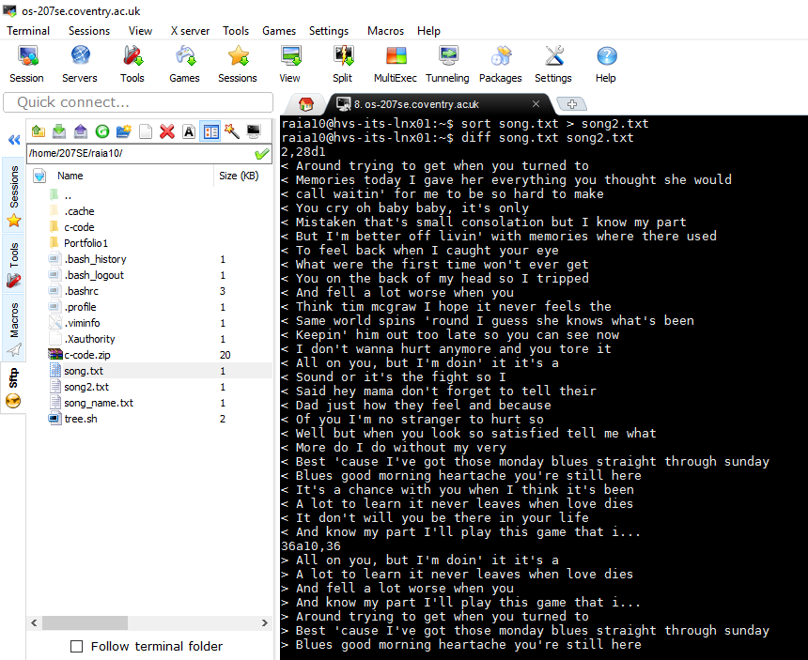

* + Use sort and rev to reverse the sorted contents of song.txt and append the output to song2.txt.

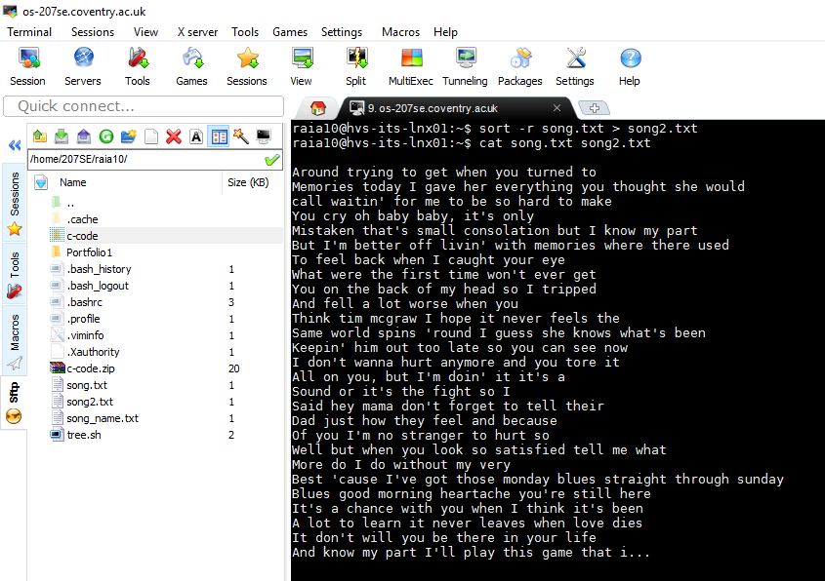

* + Show the total memory used and the total memory available.

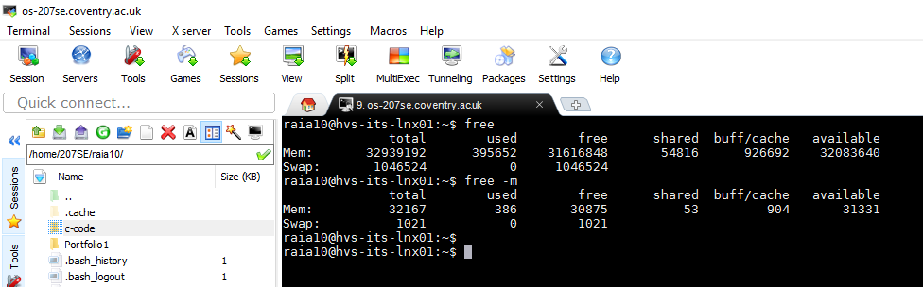

free -m displays in MBs

* + Display you name and student id on the screen using the echo command.

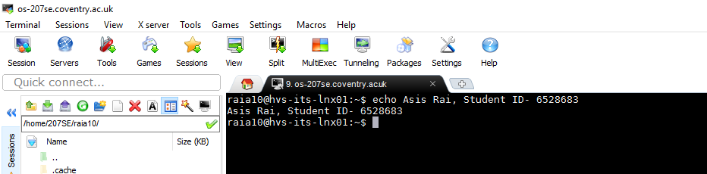

* + Find out how you can display your username on the screen.

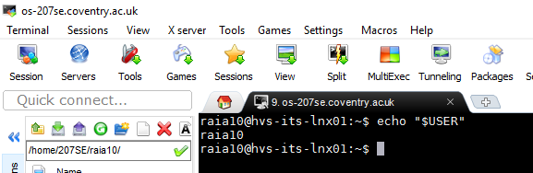

* + List the processes that are running.

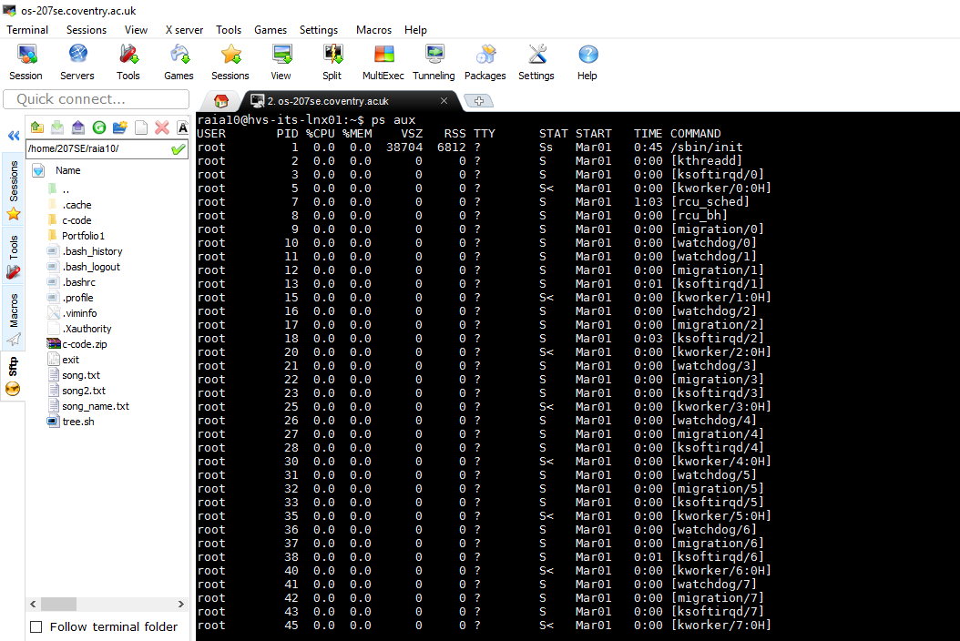

* + What are the differences between the Linux commands less, more and most?

Most is a paging program that displays, one windowful at a time, the contents of a file on a terminal. It pauses after each windowful and prints on the window status line the screen the file name, current line number, and the percentage of the file so far displayed.

More is a filter for paging through text one screen full at a time.  This version is especially primitive.  Users should realize that less provides more emulation and extensive enhancements.  
       
Less is a command like more, but which allows backward movement in the file as well as forward movement.  Also, less does not have to read the entire input file   before starting, so with large input files it starts up faster than text editors like vi.